Nexora documents evidence and file safety
Document 29 of the Nexora learning guides
Source snapshot 14 October 2026 at 06:41 UTC
Understand CRM files, application evidence, CMS media and quarantined uploads.

Recognise the screen and its scope
Open /relationships/contacts, /membership/applications/[id], /portal/applications, /website. CRM routes use port 3017; member routes use 3018; public website routes can use 3019. Brackets name a route parameter, not text to paste into a browser. Choose a real record or site id from the application.
This guide covers Upload metadata and content; Quarantine and scan states; ClamAV scanner configuration; Clean-file download; Tenant and record access; Application evidence review and CMS public media.
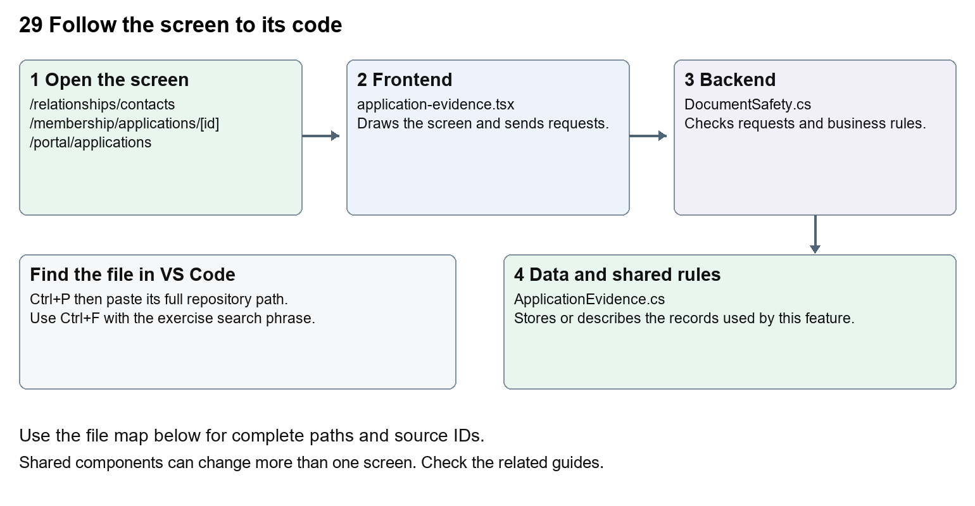
The diagram shows the file roles. The full paths below are what you paste into Ctrl+P.

Find the files in VS Code
Role | File and source ID | What it does
Screen | S0133 application-evidence.tsx | Main UI or route for this topic
Server | S0187 DocumentSafety.cs | Endpoints or server rules
Data | S0416 ApplicationEvidence.cs | Data shape or persistence structure

Screen S0133
apps/web/src/features/shared/application-evidence.tsx
Server S0187
backend/src/BuildingBlocks/Nexora.BuildingBlocks/Documents/DocumentSafety.cs
Data S0416
backend/src/Modules/Nexora.Modules.Membership/Domain/ApplicationEvidence.cs
The complete HTML manual opens these source IDs inside its Source library. The Word manual shows short labelled extracts so you can learn the flow before reading large files. Each individual Markdown guide includes its complete primary files after the walkthrough.

Follow the request and the records
1. A form sends a file and relevant record or draft id.
2. The endpoint validates size, type and access.
3. The shared safety service stores quarantine and scan state.
4. A scan result controls whether download or publication is allowed.
5. Record, application and public media endpoints apply their own access rules.

Read the code with an explanation
File metadata is the name, type, size and scan result; file bytes are the actual content. Stored bytes alone do not make a file safe. Missing scanner access deliberately retains quarantine. CRM, portal evidence and CMS media use shared safety concepts but different endpoints and permissions. On Windows, Prepare-LocalDebug.ps1 calls Prepare-LocalDocumentScanner.ps1 before API preparation. The helper can download its configured ClamAV package and signatures, checks the package checksum and starts the local scanner on 127.0.0.1:3310. The Development API configuration points to that address. Inspect its logs under artifacts/local-document-scanner when this preparation fails. Never make the UI treat quarantined as clean to remove an error.
Source reference S0133 apps/web/src/features/shared/application-evidence.tsx
Selected opening lines with their original numbers. The complete file is in the HTML source library.
0001 "use client";
0003 import { useEffect, useState } from "react";
0005 type Evidence = { id: string; name: string; size: number; scanStatus: string };
0006 type Change = { draftVersion: string };
0007 type Props = { path: string; staff?: boolean; version?: string; disabled?: boolean; canScan?: boolean;
0008 onChanged?: (version: string) => void; onBusy?: (busy: boolean) => void };

The import lines lead to shared components and helpers. Start at the exported component or route function; follow the request helper to the server rather than assuming the whole feature lives in this file.
Source reference S0187 backend/src/BuildingBlocks/Nexora.BuildingBlocks/Documents/DocumentSafety.cs
Extract from source line 17. A fragment from a long line is shown without the rest of that line.
0017 public static class DocumentSafety

On the server, look for MapGet to load records, MapPost to create or perform an action, MapPut or MapPatch to change data, and RequireAuthorization for permissions. Some shared methods register endpoints indirectly. Find SaveChangesAsync to see the database write. A request method alone does not tell you every side effect.
Source reference S0416 backend/src/Modules/Nexora.Modules.Membership/Domain/ApplicationEvidence.cs
Selected opening lines with their original numbers. The complete file is in the HTML source library.
0001 using Nexora.BuildingBlocks.Domain;
0002 namespace Nexora.Modules.Membership.Domain;
0004 public sealed class ApplicationEvidence : TenantEntity
0005 {
0006 public Guid DraftId { get; set; }
0007 public string Name { get; set; } = "";

Follow model fields to their request names and database mapping. An id points to a particular record. A tenant id limits the organisation. A version or concurrency stamp protects newer edits. Some model files describe contracts rather than tables; check the owning DbContext before assuming storage.

Make or trace your first change
1. Press Ctrl+P and open apps/web/src/features/shared/application-evidence.tsx.
2. Press Ctrl+F and search for export function. In this snapshot it appears at line 10.
3. Read-only exercise: find the upload, list and download requests. Trace the scan-status rendering to the backend safety code. Explain why a successful upload can still be unavailable for download.
4. Record the file, request path and server handler you found. This exercise is read-only; no stored records need to change.
Extract from source line 10. A fragment from a long line is shown without the rest of that line.
0010 export function ApplicationEvidence({ path, staff = false, version, disabled = false, canScan = false, onChanged, onBusy }: Props) {

These exercises have not been applied to the application. Their search phrases are verified against the captured source. Line numbers can move; the phrase and file path are your main navigation aids.

Check a change and diagnose problems
Confirm the original screen still loads, the changed words appear in the intended place, and another screen using the same component still behaves correctly. If an action fails, inspect the browser Network response, the relevant helper and server validation message. Use the common error table at the beginning of the manual. Reload on a version conflict instead of removing the version check.
A syntax error after a text edit usually means a quote, brace or closing tag changed. Compare your diff with the original. An unchanged browser result can mean the wrong port, a saved published configuration overriding a default, or a running API that has not reloaded.

Understand the current limits
No live scanner was exercised for this documentation task. A controlled clean-scan test is different from an operational ClamAV deployment. Leave access and quarantine checks in place.

Continue learning
Related guides 05 Nexora CRM contacts, 10 Nexora membership applications and decisions, 25 Nexora member portal journeys, 27 Nexora website editor and publishing, 28 Nexora public website, 30 Nexora backend database and maintenance.

